I selected 2 cases (chip1 and chip2) from the scanner and camera cases which have been normalized respectively and plotted the histograms of the intensity and norm maps.

 

 

Aligned images (scanner)

 

 

Aligned images (camera)

Case 1 (Chip1 from scanner):

Histogram of intensity in different directions

 

 

Histogram of norm maps



Norm map X



Norm map Y

Case 2 (Chip2 from scanner):

Histogram of intensity in different directions

 

Histogram of norm maps



Norm map X



Norm map Y

Case 3 (Chip1 from camera):

Histogram of intensity in different directions

 

Histogram of norm maps



Norm map X



Norm map Y

Actually the mean is very big.

Case 4 (Chip2 from camera):

Histogram of intensity in different directions

 

Histogram of norm maps



Norm map X



Norm map Y



Text region



Histogram of text region



Background



Histogram of background

Observations:

1. For the main peak, the camera’s cases are narrower but the peaks are larger while the scanners’ cases are wider, the peaks are smaller. The scanner’s intensity is of higher contrast.
2. Mean of the camera cases in different directions is quite different. So when calculating the norm map of the camera cases, we need to adjust the overall intensity.
3. For every case’s intensity histogram, they all have those tails in the right part. These tails may be the text regions. And camera’s tails are longer.
4. The spatially blurred camera photos may cause the narrower peaks and longer tails in camera cases. In the background areas, camera can’t get a precise image, so these areas are blurred and produce the narrow and high peak. In the text regions, camera can catch them clearly and produce the long tails.

After getting the derivation of the camera case’s fully diffuse model, I fixed the point’ location, changed the camera-chip distance and fixed the camera- chip distance, changed the point’s location to calculate the norm map X’S absolute error using the chip1’s calculated norm map.

Fixing the point’s location:



The 3 curves are nearly the same, explain that the calculated error does not change greatly due to different norm vectors.

In my case, the camera-chip distance is 20cm. From the curve above we can observe that, in this case, there will be a slight error in the chip’s corner. The best distance can be 40cm or 60cm.

Fix the camera-chip distance:







It can be observed that after fixing the position of the point source, the error increases linearly with the distance of the observation point from the center point.

I made a scatter plot of the two images to be subtracted. There are points in both sides that are far from the diagonal. I guess these points are the specular component. So I replaced them using the average value of the picture and made another scatter plot.

The original plot:

 

Removing the points of high value:



I also choose chip4 and made the scatter plot:



Removing the points of high value:



Then I make the image of scaled color of chip1 and the 3D height map.



In these pictures, I can’t observe a obvious difference. I extract the subbands of chip1 and chip4’s height maps from both camera and scanner cases and calculate the correlation.



After removing the points:



For chip1’s case, the correlation is high for those high frequency subbands. After removing the points, the correlation became a little bit higher.

But for chip4’s case, the correlation is low. The reason may be the untrusted confocal data, camera pictures and the error of generating a norm map as described above.

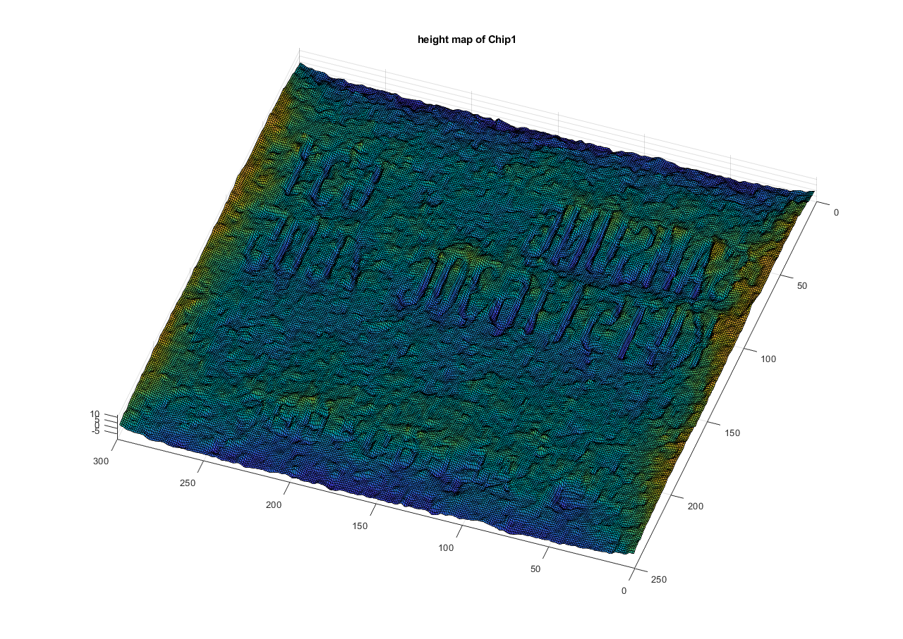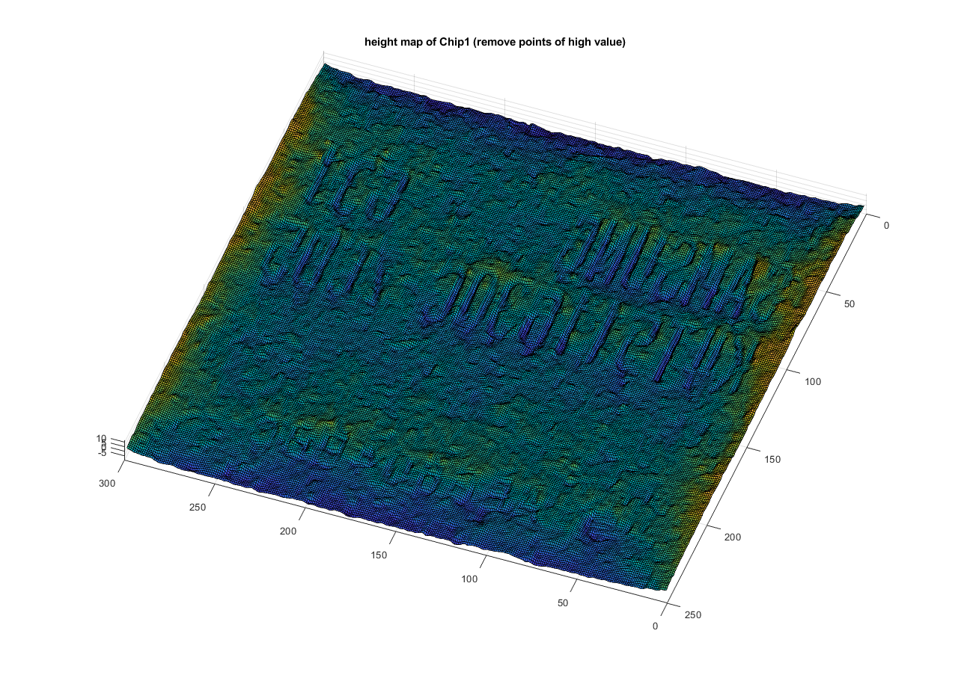

Conclusion:

There are two main sources of error in generating norm maps:

1. Point source distance that cannot be infinity. If we move the point source too far, the light intensity will be weak so we can’t capture good pictures.
2. The specular component that cannot be removed. If it is a strong specular reflection, we can directly remove them. But if it is not obvious that the specular reflection is doped in the diffuse reflection, this will be used as a diffuse reflection into the calculation.